If the video is in YouTube or Panopto, it can be submitted through CaptionHUB for captioning at a reduced rate.
Follow these steps to request your videos be captioned:

How to Use Caption HUB

- You can find the Caption HUB tab in your Canvas course Navigation:
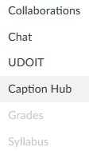

- When you click on the Caption Hub tab it will take you to a Caption Request page:
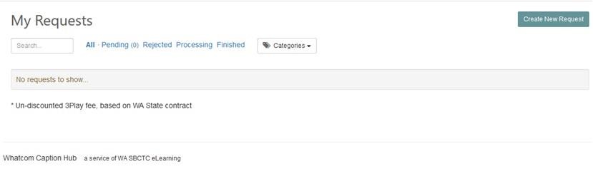

- Click the ‘Create New Request’ button & fill in as much as you can. Be sure to select the correct video format (YouTube or Panopto)
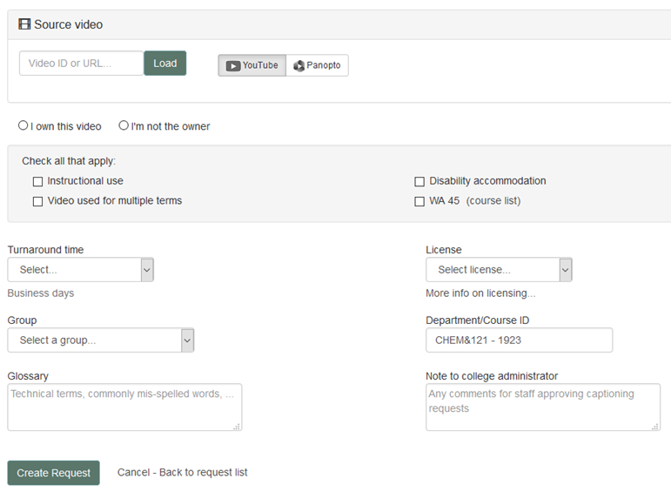

Things to know:
- Currently Caption Hub only accepts YouTube & Panopto video links.
  - If your video is in a format or location other than YouTube or Panopto, please complete the Captioning Request form and send to Kerri Holferty in the ADS office. Your video will still be able to be captioned.
- Please choose & allow for 10-day turnaround.
- If you are not the owner of the video, your video can still be captioned.
- If your video meets all four categories listed, it will be captioned for free. If it meets 1-3 of the categories listed, it will be discounted accordingly.
- For the Group option – please choose non-instructional or instructional.
- You can leave us a message in the Note to College Administrator box.

If you have any questions about the captioning process or Canvas, contact Tye Durbin tdurbin@whatcom.edu
If you have any questions about accommodations or the ADS process, contact Kerri Holferty, kholferty@whatcom.edu

